 | ICMES’2016  1-3 December 2016  Campus Du Savoir Technopole, Oujda, Morocco | 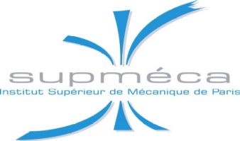
Bulletin of inscription

First Name
Name
Professor / Student /……..
Laboratory
Institution
Postal address
Zip code
Country
phone
Fax
E-mail

Paymentmodalities
(Check the corresponding box)
[ ] : student ⁽³⁾ | [ ] : University | [ ] : Industriel | [ ] : ………………….
1000 DH | 1500 DH | 2000 DH | 2000 DH
Paid on the name of : LE CENTRE MAROCAIN DU DEVELOPPEMENT ET DES SCIENCES (CEMADES)

⁽⁴⁾ By bank transfer: bank details:
Bank : BanquePopulaire : AgenceSidi Maafa-Oujda
Address : Angle Bd Hassan II & Amamou Cheikh, Hay AlAndalous
City : Oujda
Country: Morocco
RIB : 157 570 21116 66573700085 10
SWIFT : BCPOMAMC
IBAN : MA

Date and Signature
(Mandatory)

Please, send us this bulletin before October 31, 2016

E-mail: icmes2016oujda@gmail.com

⁽¹⁾Web site: http://www.jmaterenvironsci.com/icmes2016/
⁽²⁾For more information please contact:Professor B. HAMMOUTI, Tel: 212668632273 // 212661360191
⁽³⁾ Please send us copy of your student card or inscription
⁽⁴⁾Please put your ID number in all your banc transfer ICMES’2016. The receipt of bank transfer must be sent by mail to: icmes2016oujda@gmail.com

